# MK 34: Python Bootcamp, week 1

Any of the material we assign may appear in your final exam, especially the questions at the end of each session!

The readings are mostly in the online book by Charles Severance: <https://books.trinket.io/pfe/index.html>

Even if you think you already know Python, we will be grading based on these and other assigned readings, examples in we provide, and following directions. So please take care.

When you read these chapters, you should try to experiment with the code in “Trinket”:

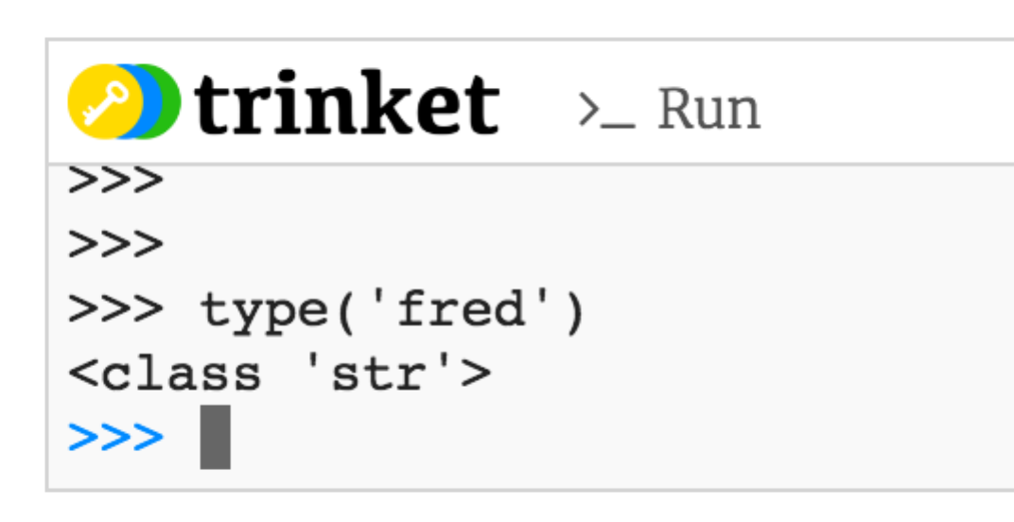

You can type things here and press “return” to see the answer. I added “type(‘fred’)” and got the result that it is of class “str” for “string.”

In this Trinket window, I tried some math using a variable already defined, “minute”:

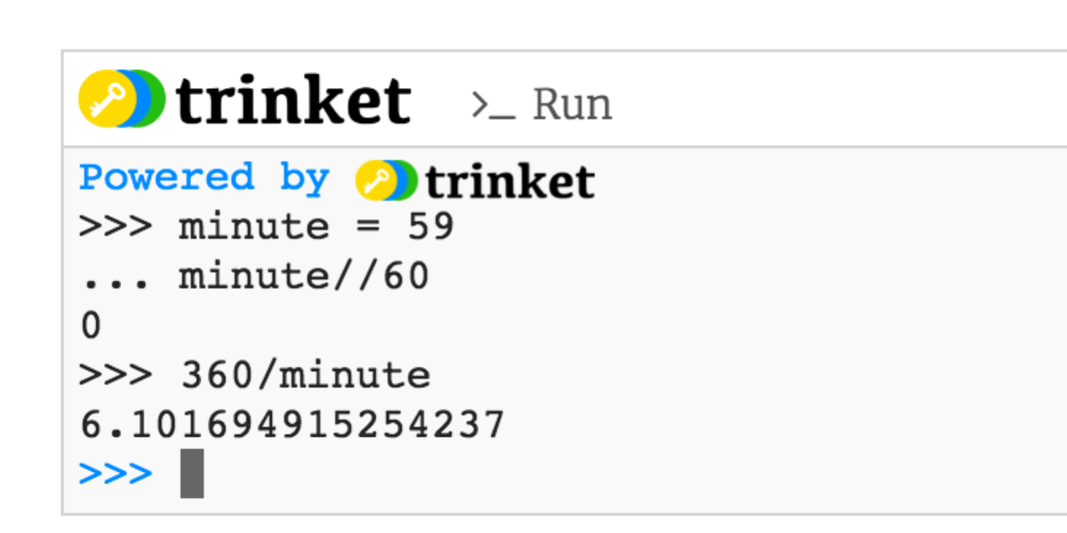

Python is acting like calculator: when I dived 360 by the value of minute, which is 59, I get 6.10… (and more digits).

Notice that we are using international decimals with a period, not commas, for number notation.

If you want to try some of the code you see in the book that is not in a Trinket form, you can copy and paste into a Jupyter Notebook.

When you copy it, you must delete the >>> that appears in front of the lines:

Book:



Your notebook, after you paste it (and remove the >>>) and press SHIFT-ENTER to run it:

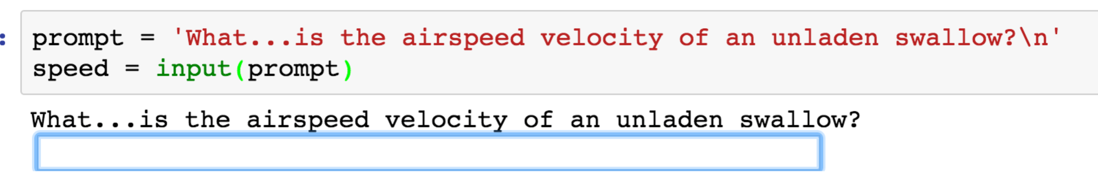

To check the value was assigned, you will then check “speed” in your notebook:

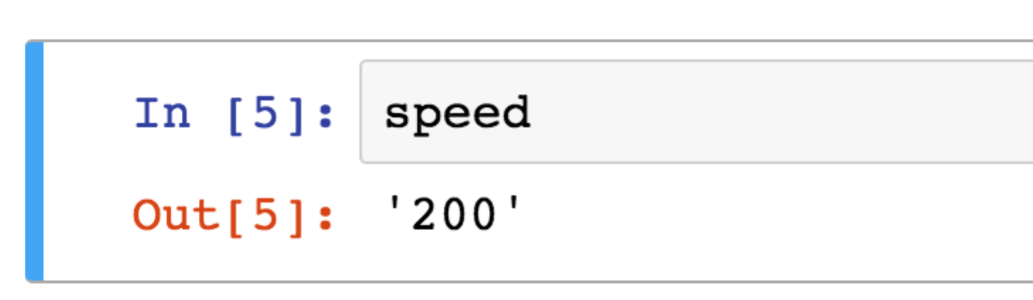

That output reports 200 is a string, because of the quotes. I can’t do math with it. How would I convert it to an integer number? The answer is in the text.

There is a new widget for running code in chapter 3:

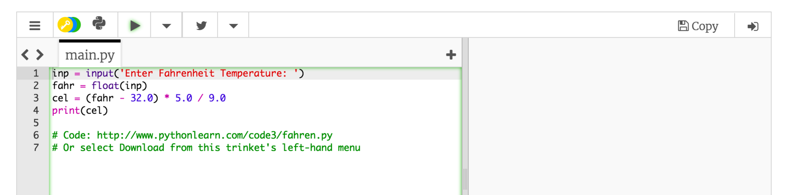

You can edit the code on the left side and run it using the arrow on top. The answer will appear on the right side!